ECS High Availability Setup
Objective
Deploy a highly available ECS cluster with:
- Minimum 6 running tasks
- Multi-AZ distribution
- Application Load Balancer (ALB)
- Dynamic port mapping
- Docker Image: sabair0509/hiring-app:works

Architecture Overview
- ECS Cluster: hiring-app-cluster
- Task Definition: hiring-app-task
- Service: hiring-app-service
- Desired Tasks: 6
- Launch Type: Fargate
- Load Balancer: ALB
- Target Type: IP
- Multi-AZ: ✅ Enabled

Step 1: Create ECS Cluster
- Go to ECS → Clusters → Create Cluster
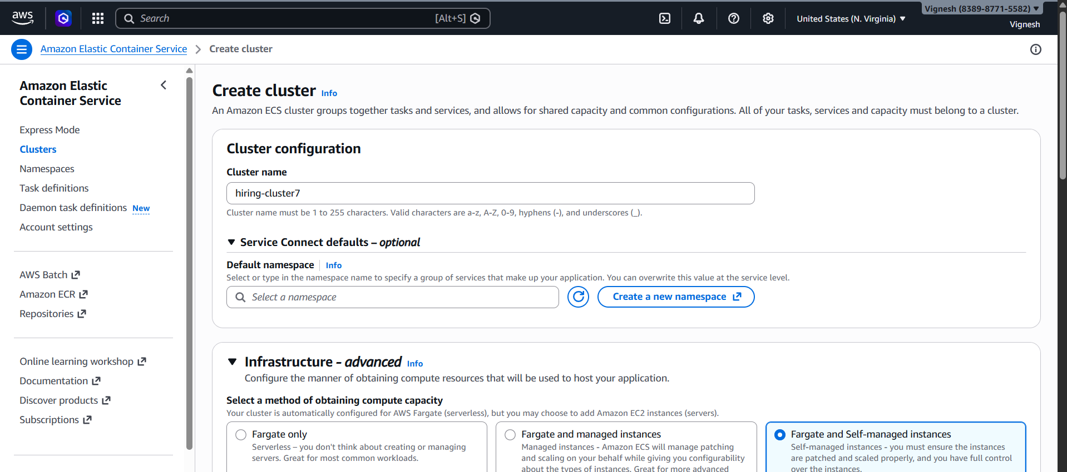
- Configure:
  - Name: hiring-app-cluster
  - Infrastructure:
✅ Fargate + EC2
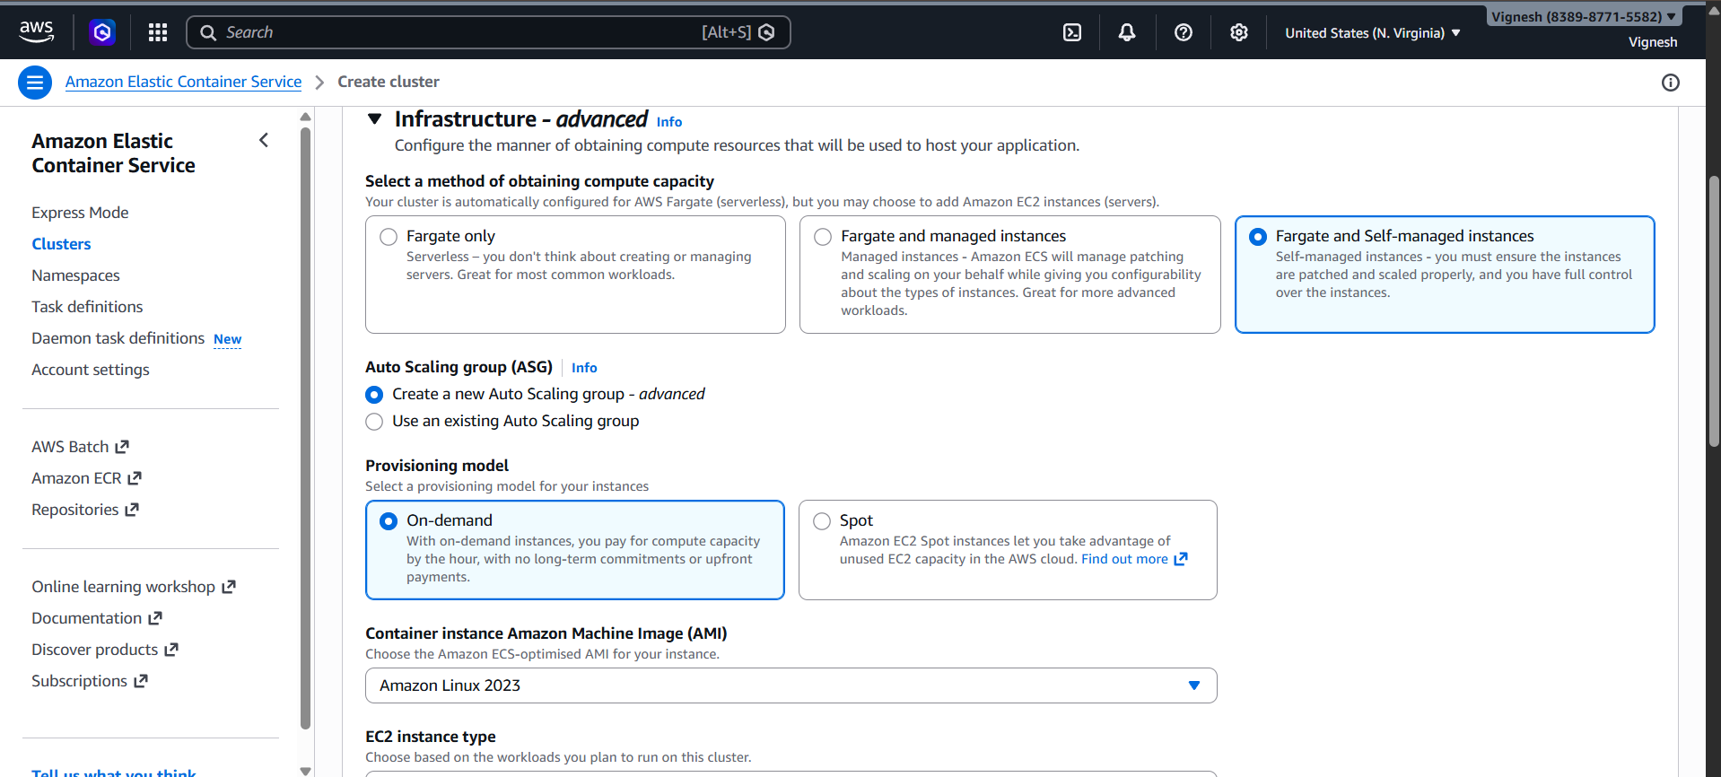
- If EC2 selected:
  - AMI: Amazon Linux 2023
  - Instance type: t3.micro
  - Min capacity: 2
  - Max capacity: 6
  - Key pair: Select existing
  - Disk: 30 GB
- Click Create
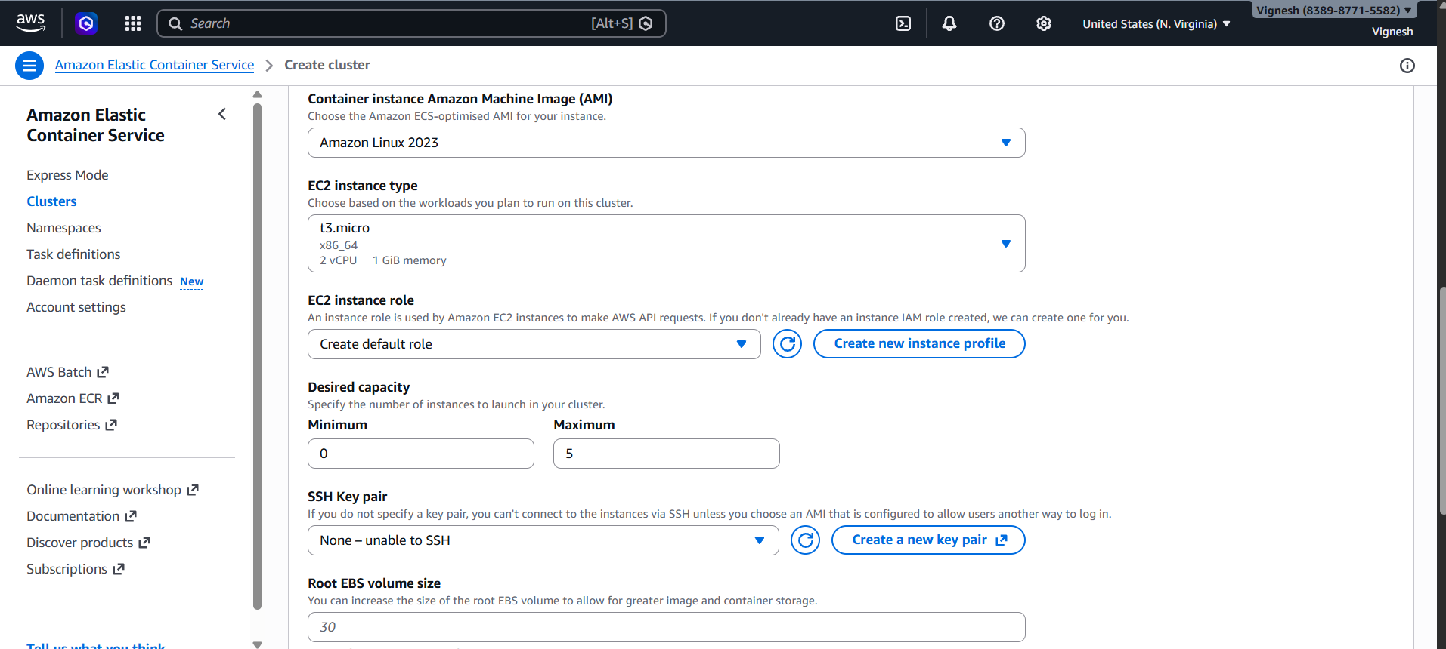
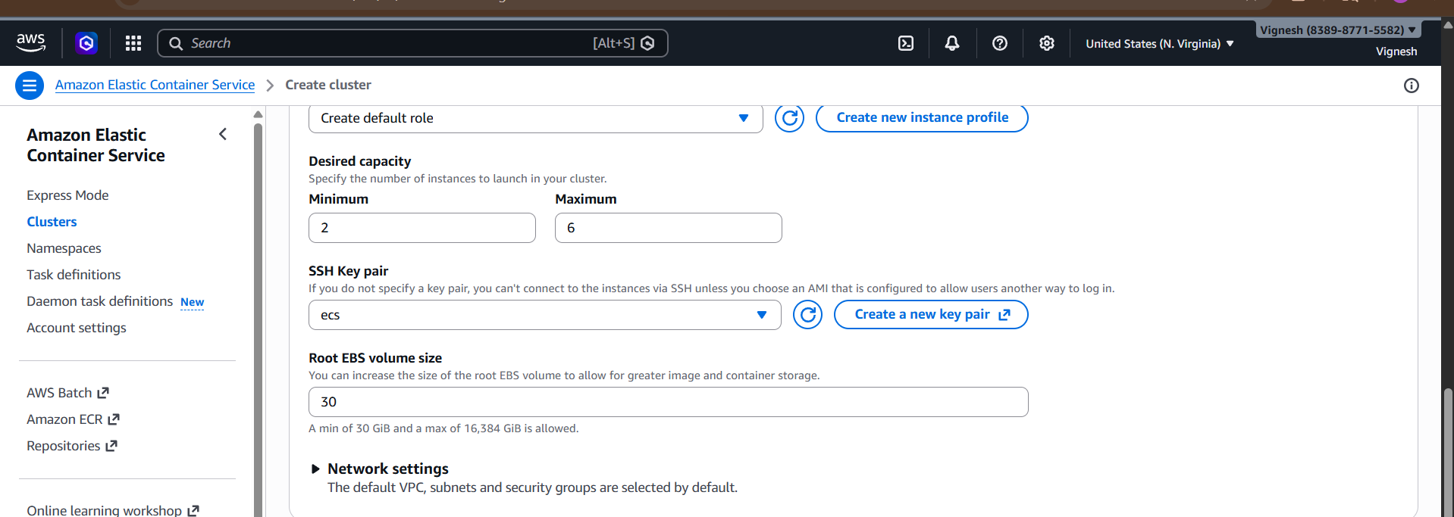

Cluster created successfully

Step 2: Create Task Definition
- Go to Task Definitions → Create
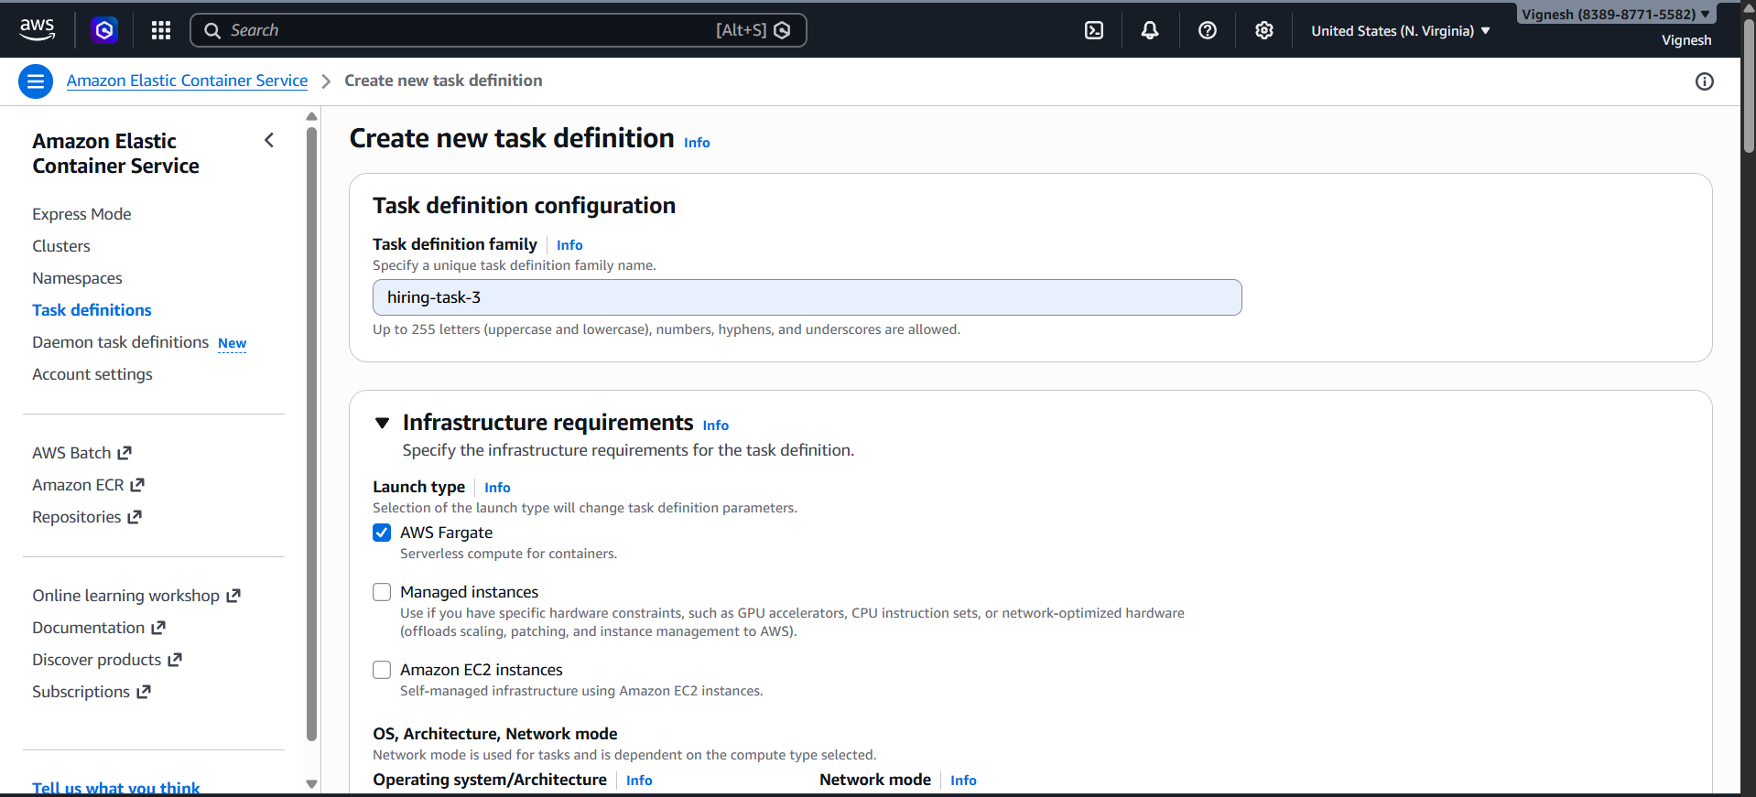
- Configure:
  - Name: hiring-app-task
  - Launch Type: Fargate
  - CPU: 0.5 vCPU
  - Memory: 1 GB
  - Execution Role: Default
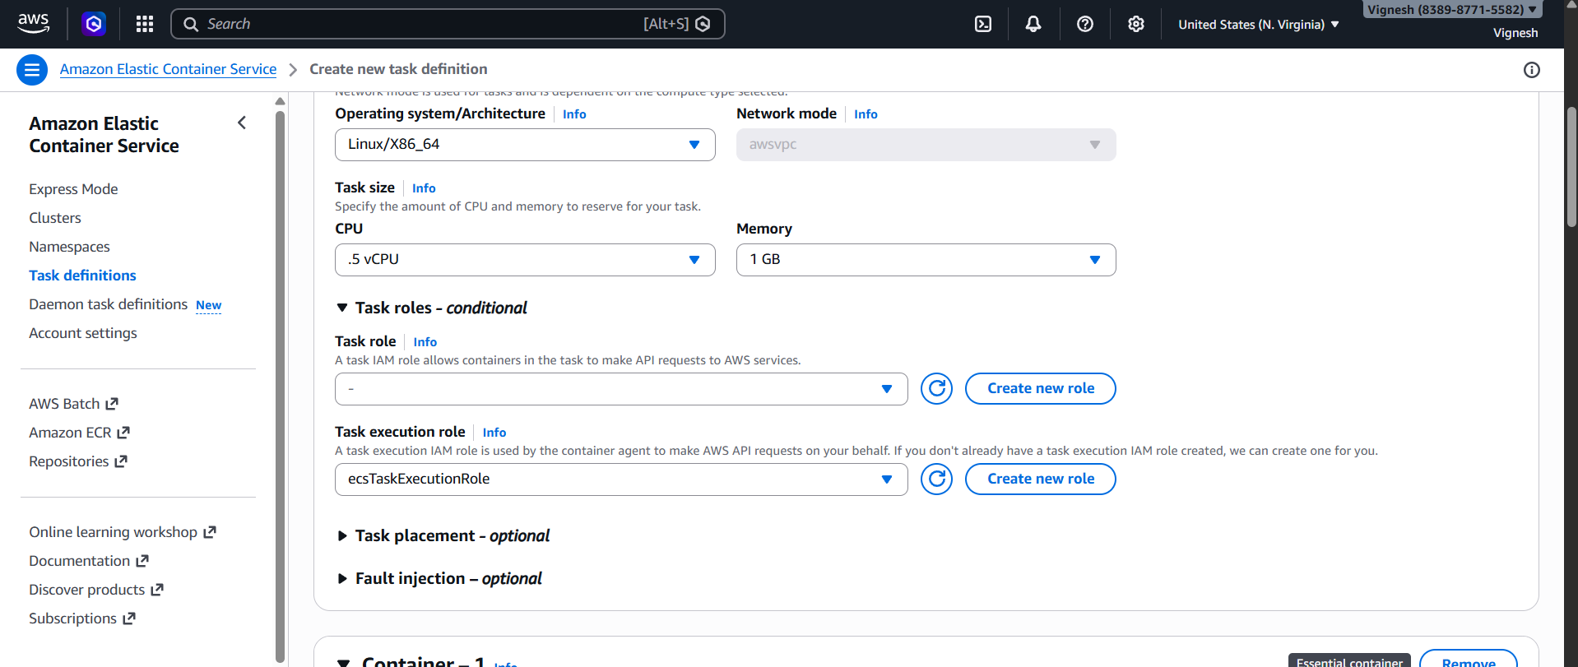
Container Configuration:
- Name: hiring-app-container
- Image: sabair0509/hiring-app:works
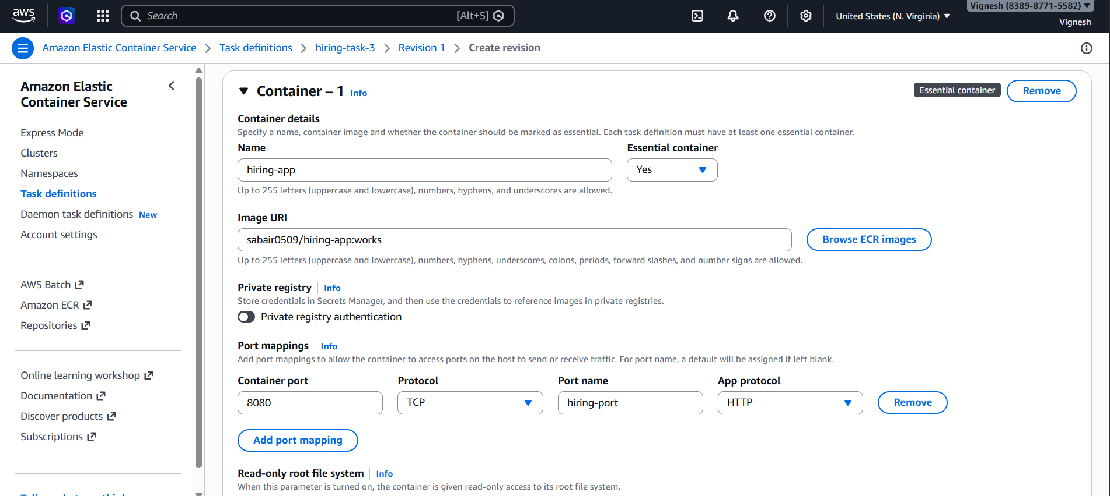
Port Mapping:
- Container Port: 8080
- Host Port: 0 (dynamic port mapping)
- Protocol: TCP
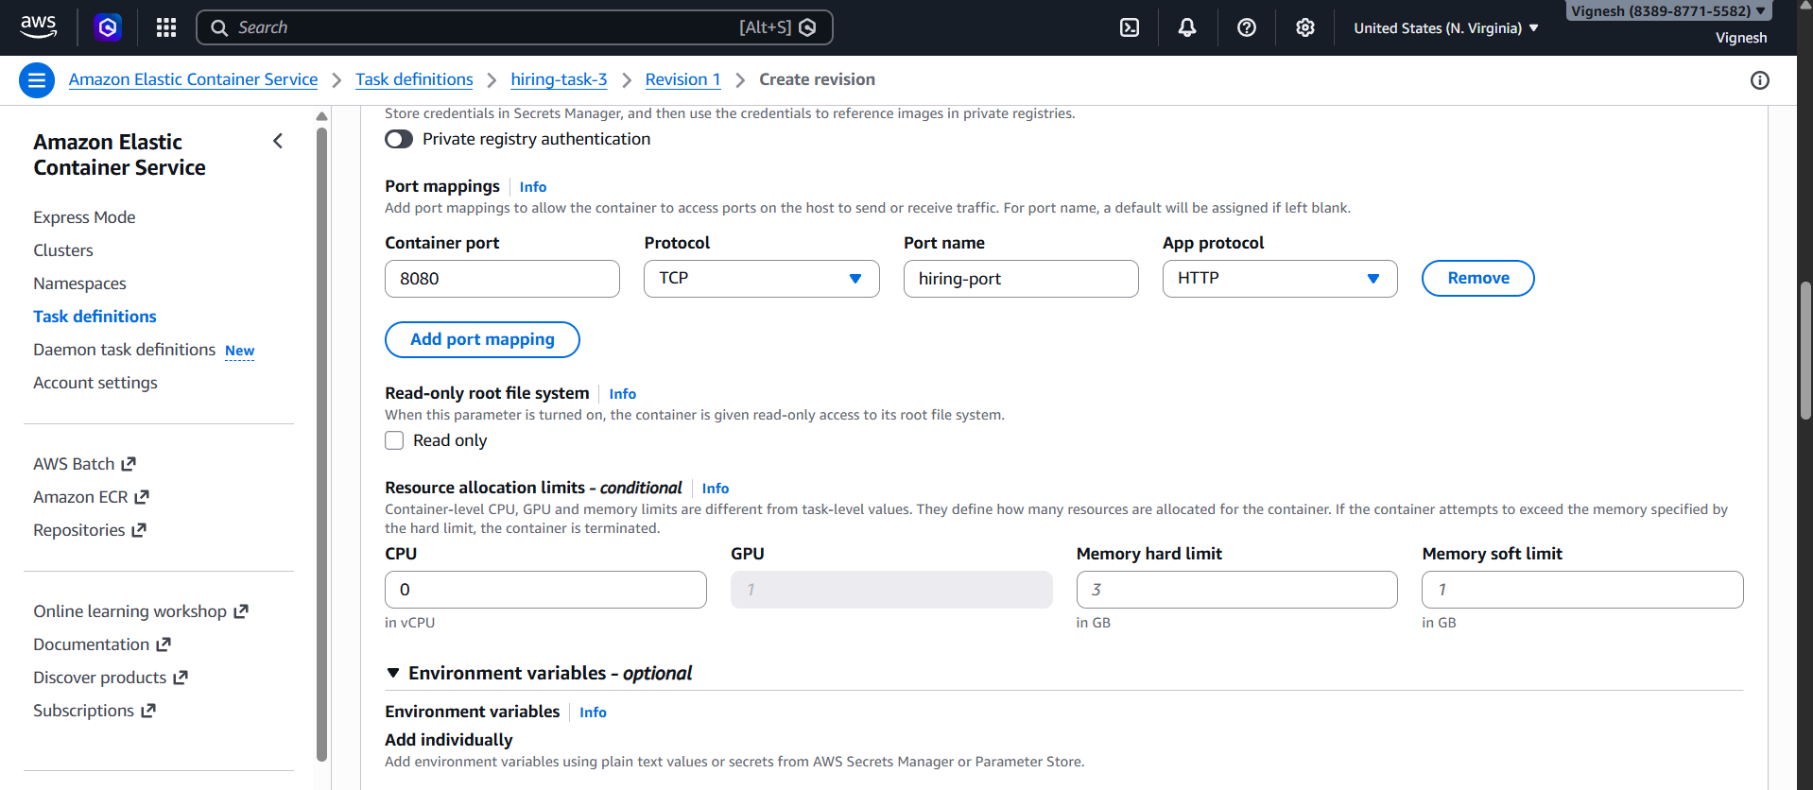
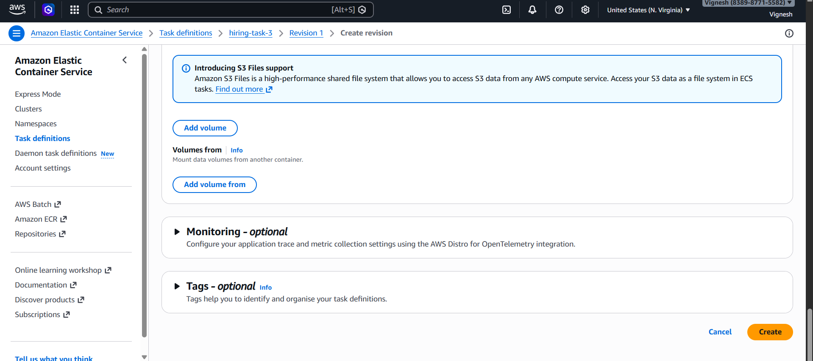
Task definition created

Step 3: Create Application Load Balancer
- Go to EC2 → Load Balancers → Create
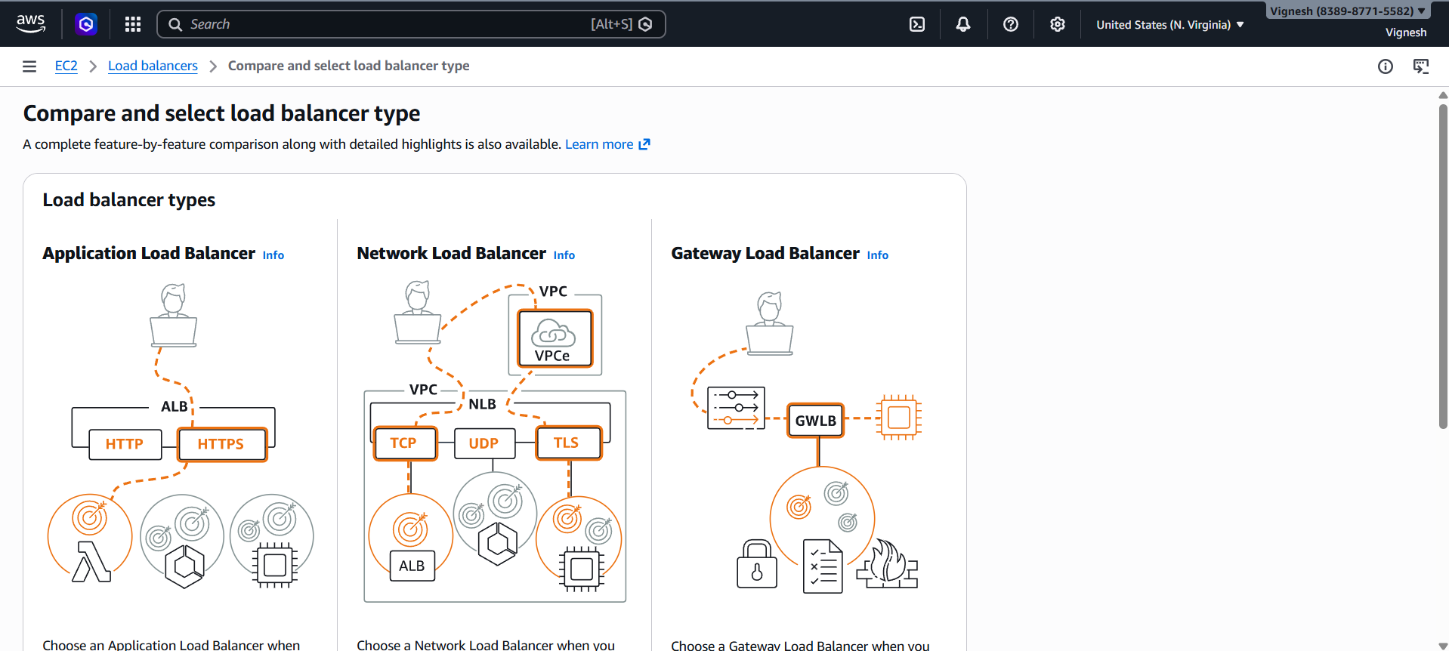
- Select:
  - Type: Application Load Balancer
  - Scheme: Internet-facing
  - IP: IPv4

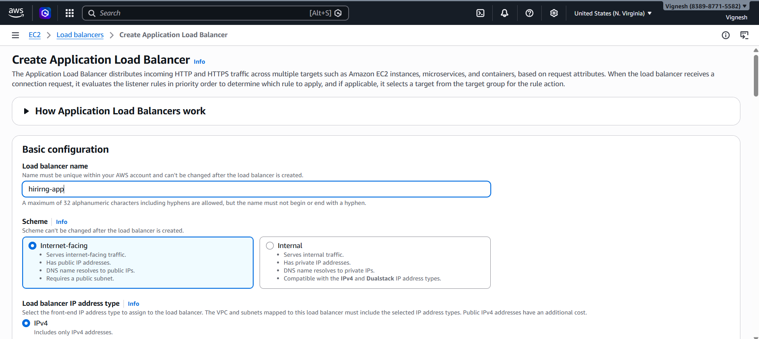

- Network:
  - VPC: Default
  - Subnets: Select at least 2 AZs

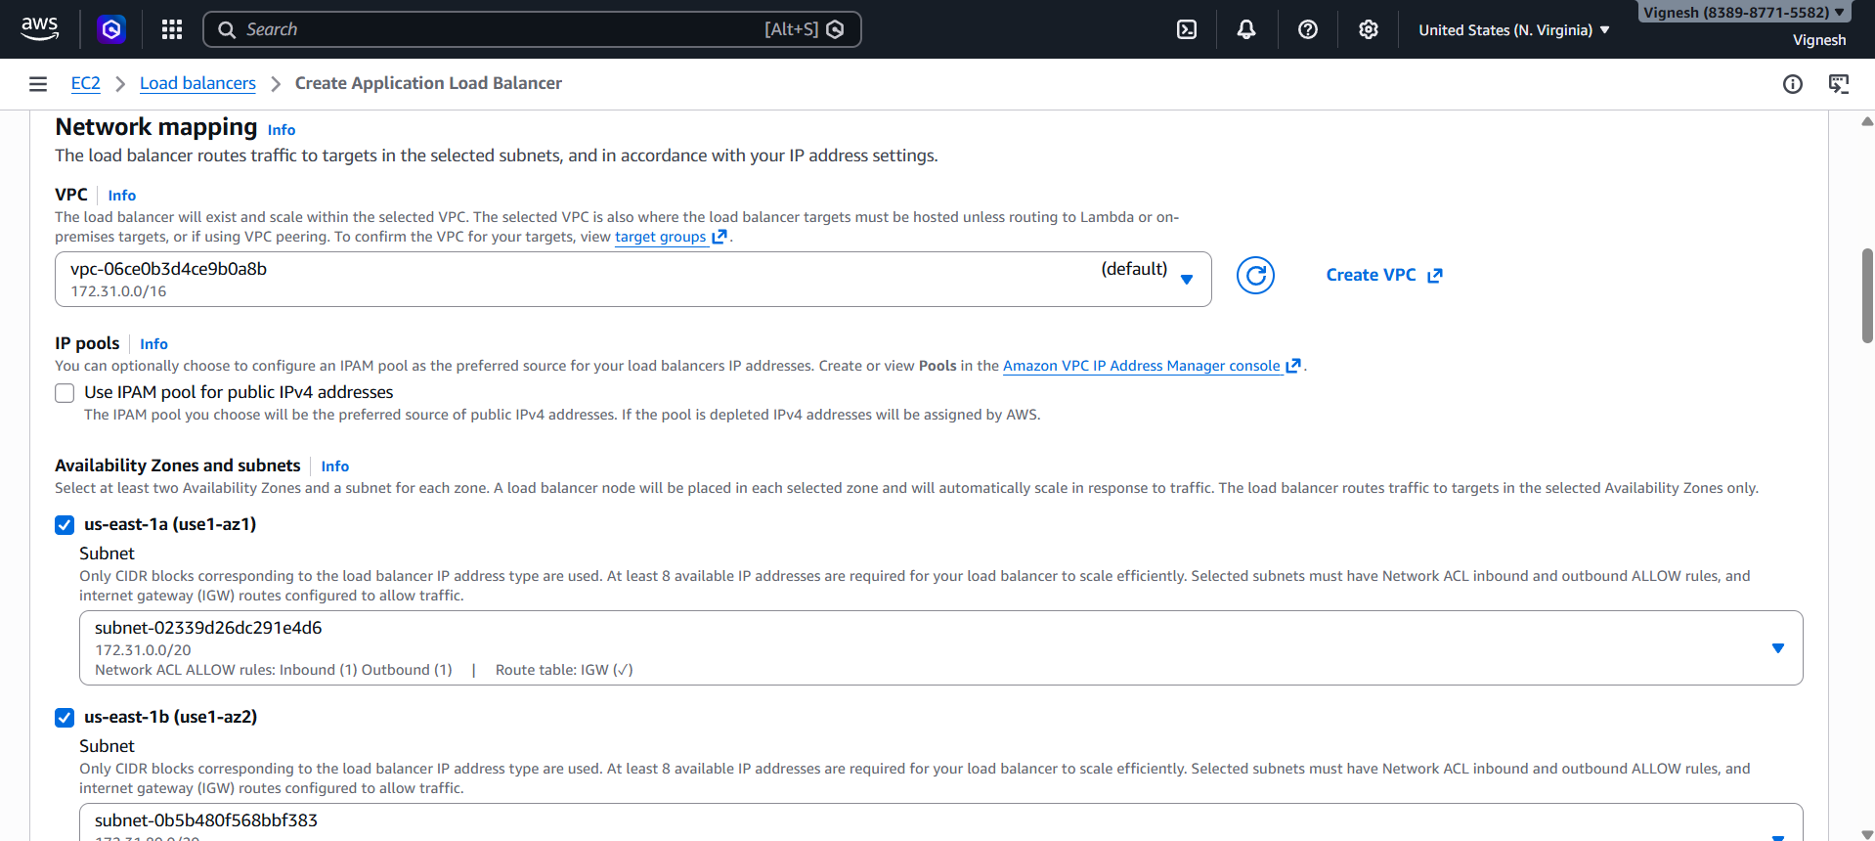

- Listener:
  - HTTP (Port 80)
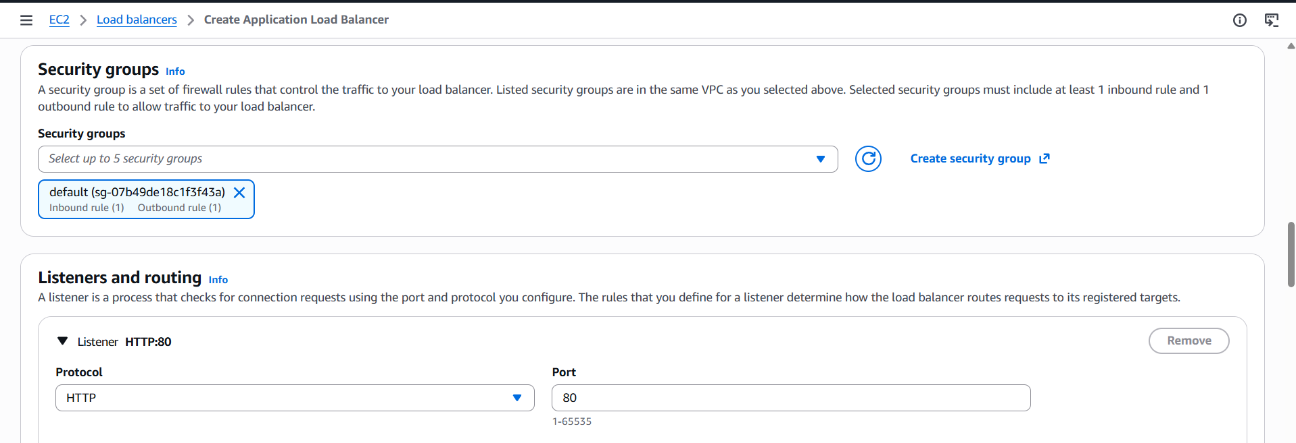

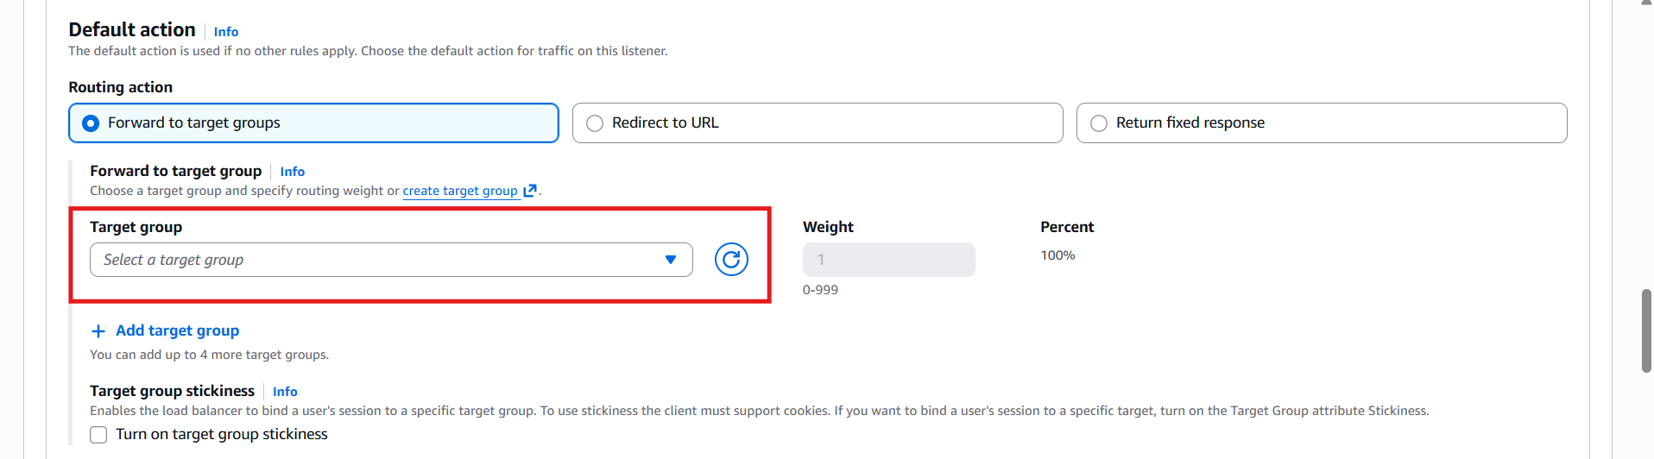

- Click Create Target Group

Step 4: Create Target Group
- Target Type: IP ( Important for Fargate)
- Protocol: HTTP
- Port: 80
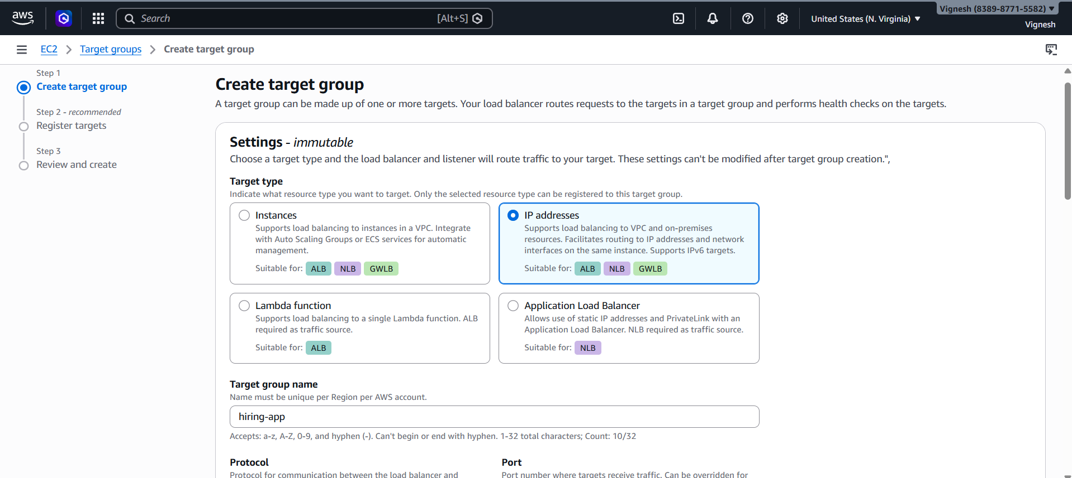

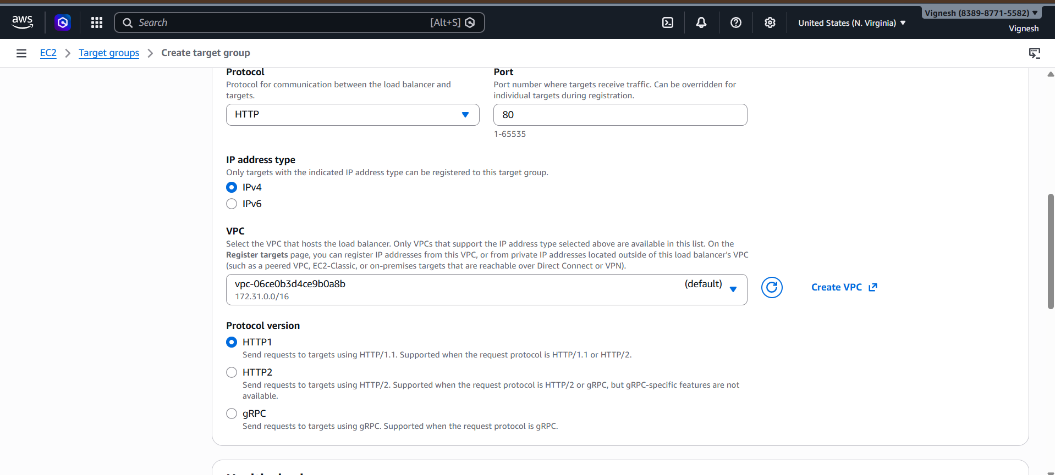

Health Check:
- Path: /hiring
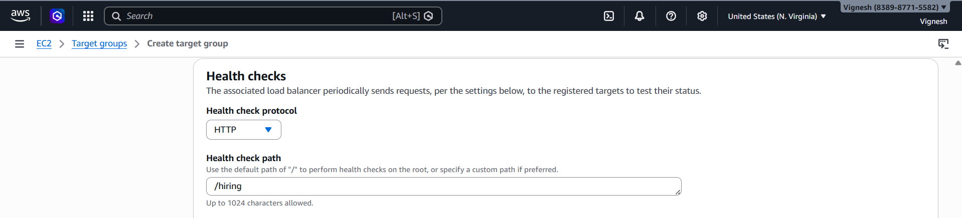

- Healthy threshold: 2
- Unhealthy threshold: 5
- Timeout: 5 sec
- Interval: 15 sec
- Success codes: 200–399

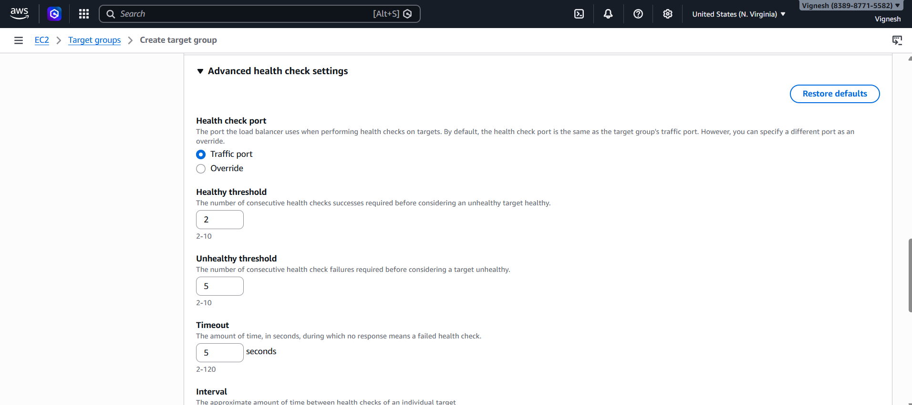

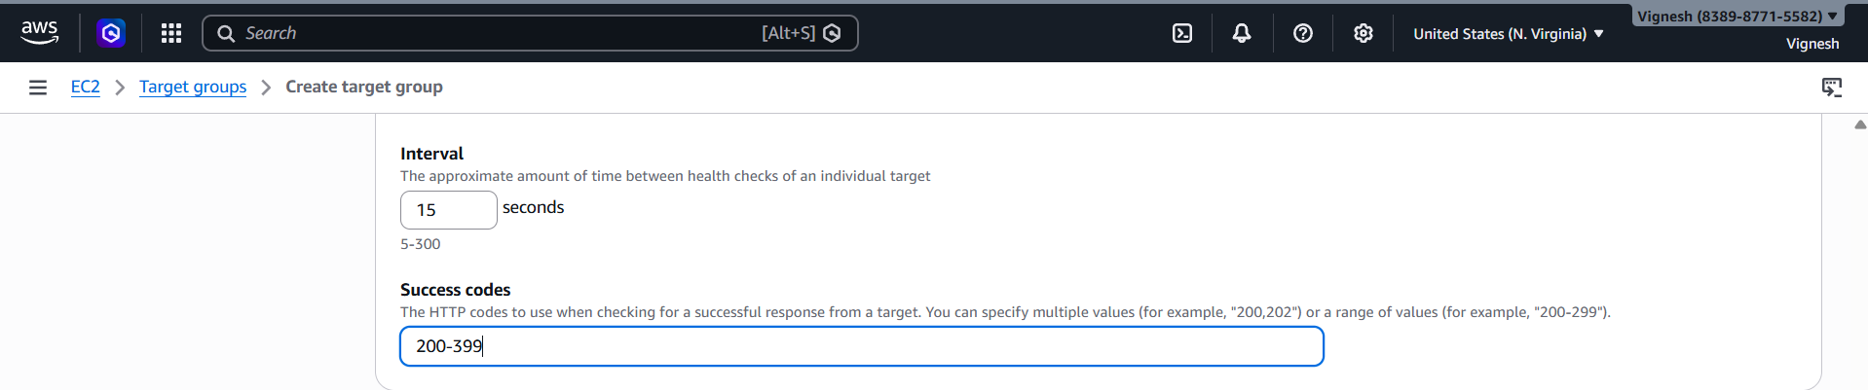

- Create target group

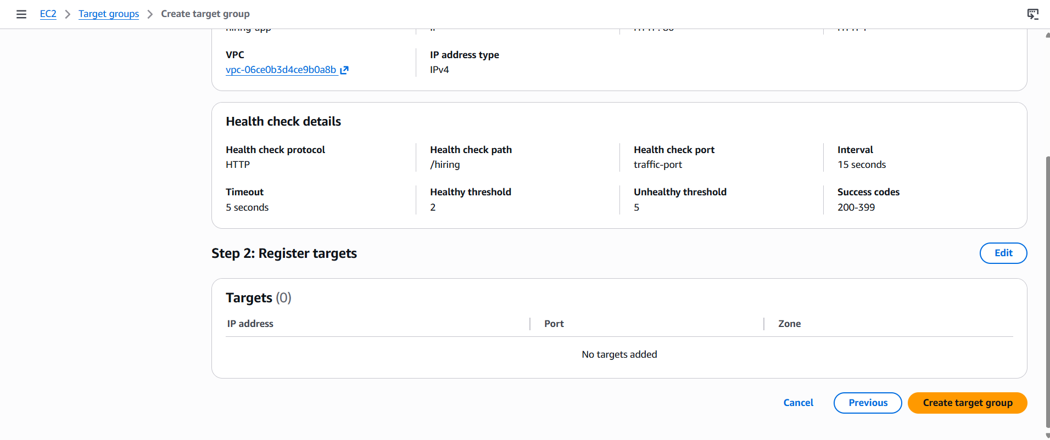

- Attach it to ALB
Load balancer ready

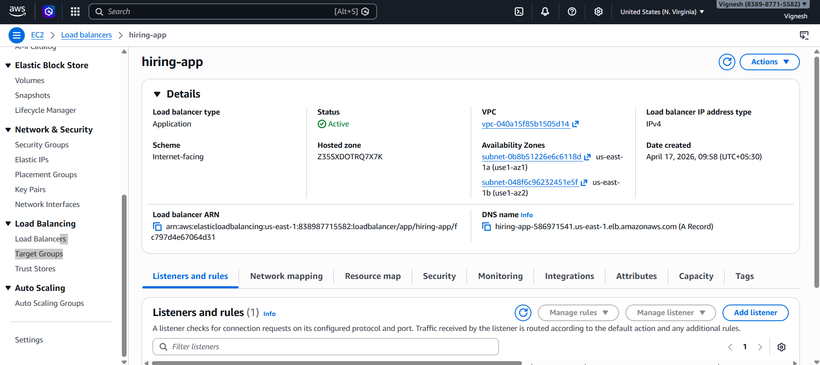

Step 5: Create ECS Service
- Go to ECS Cluster → Create Service
- Configure:
  - Task Definition: hiring-app-task
  - Service Name: hiring-app-service

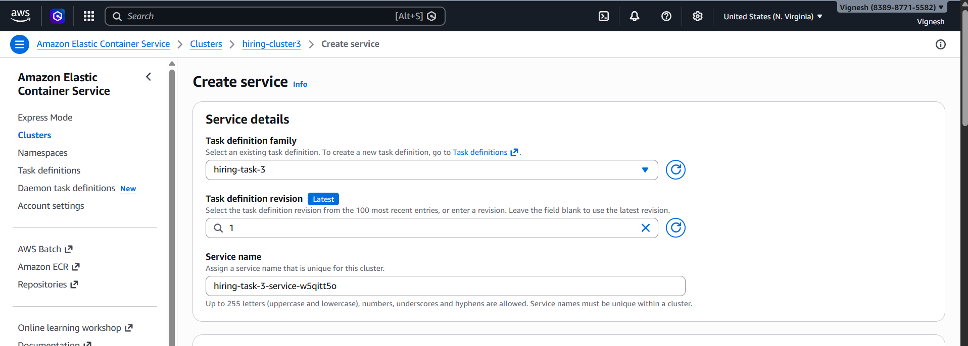

Deployment:
- Strategy: Replica
- Desired Tasks: 6
- AZ Rebalancing: ✅ Enabled
- Grace Period: 30 sec
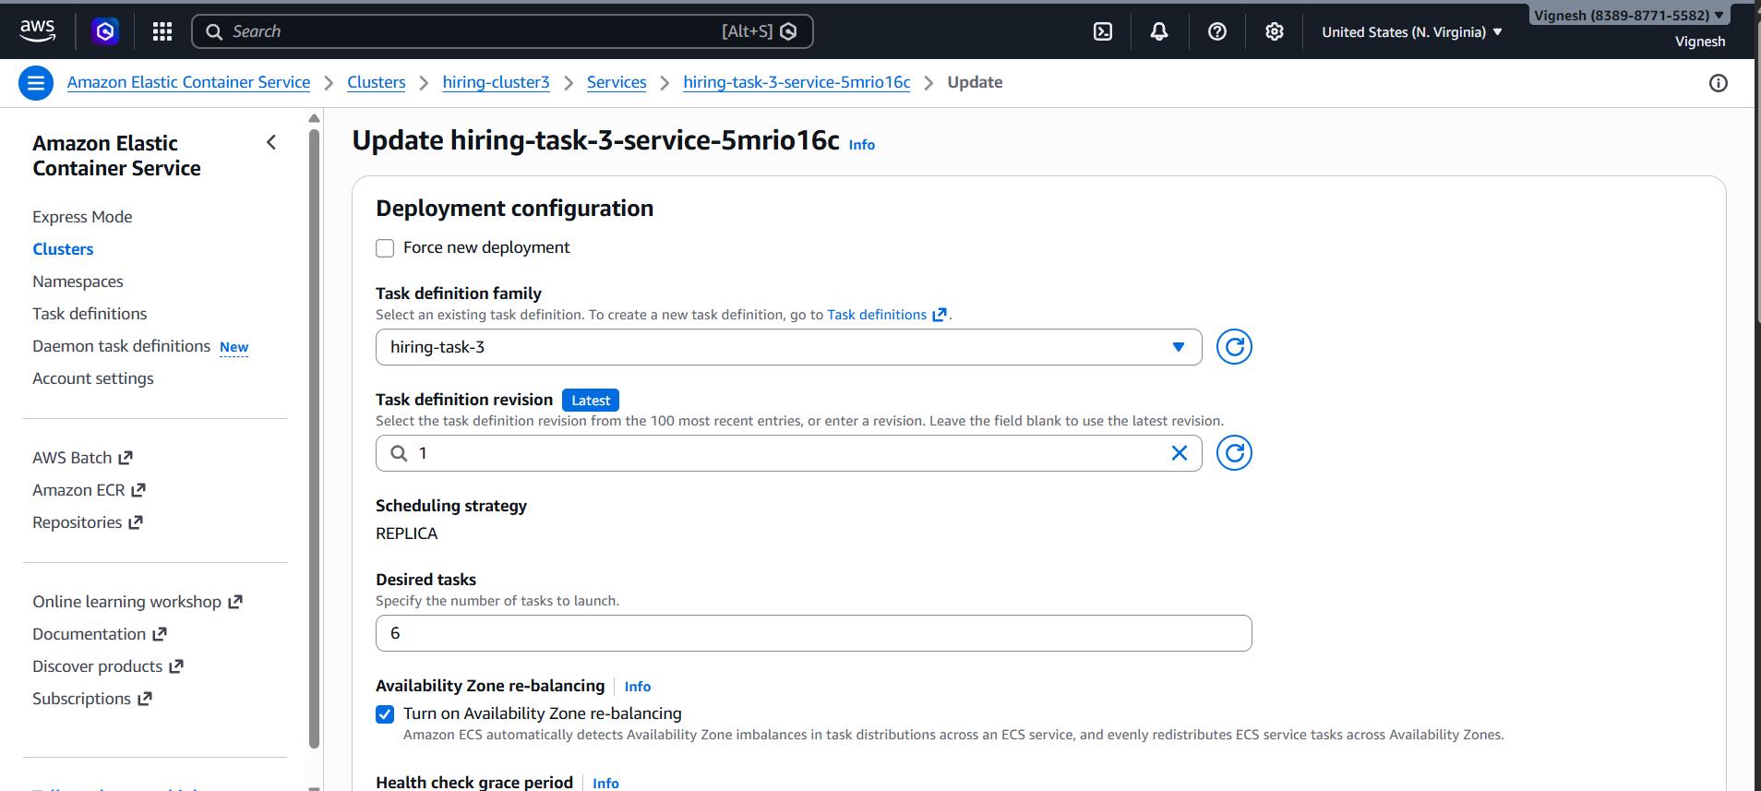
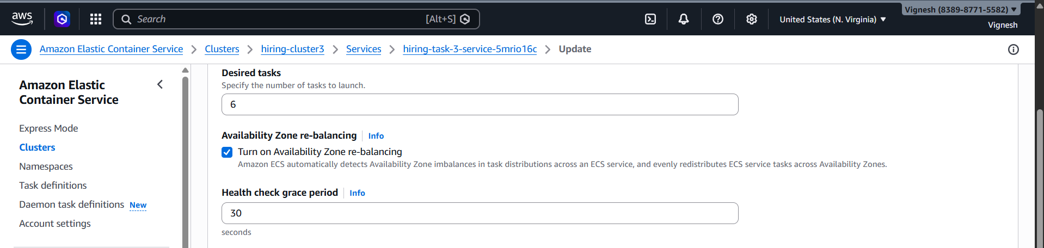
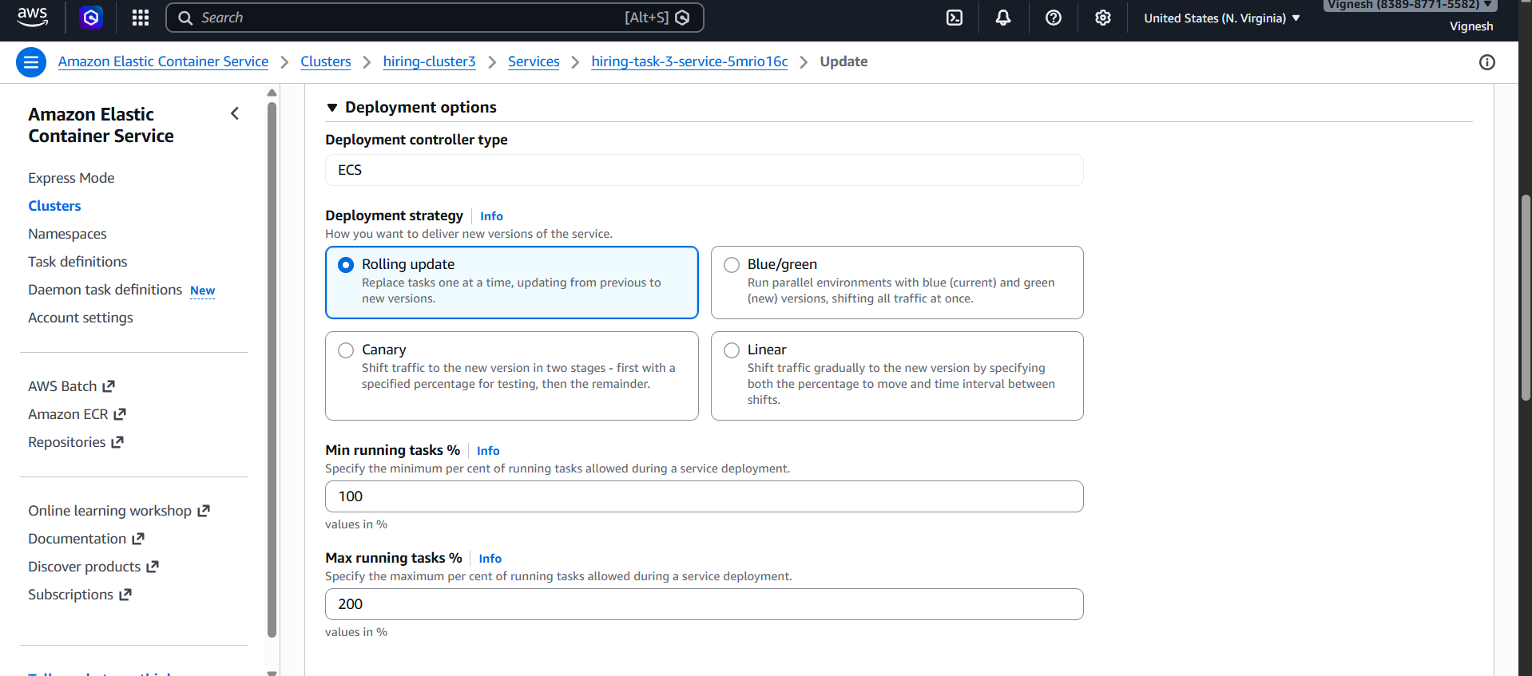

Networking:
- VPC: Default
- Subnets: Select 2 AZs
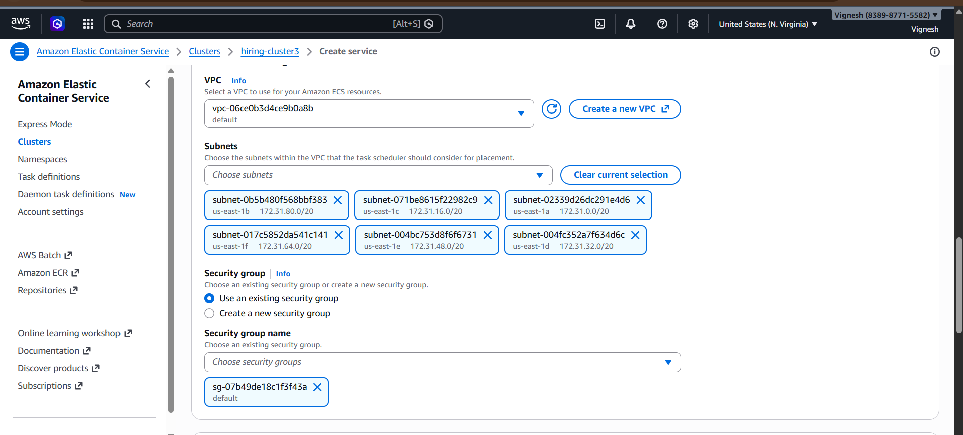
Load Balancer:
- Enable: ✅
- Type: ALB
- Select:
  - ALB created earlier
  - Listener: HTTP:80
  - Target Group: Created one
- Click Create
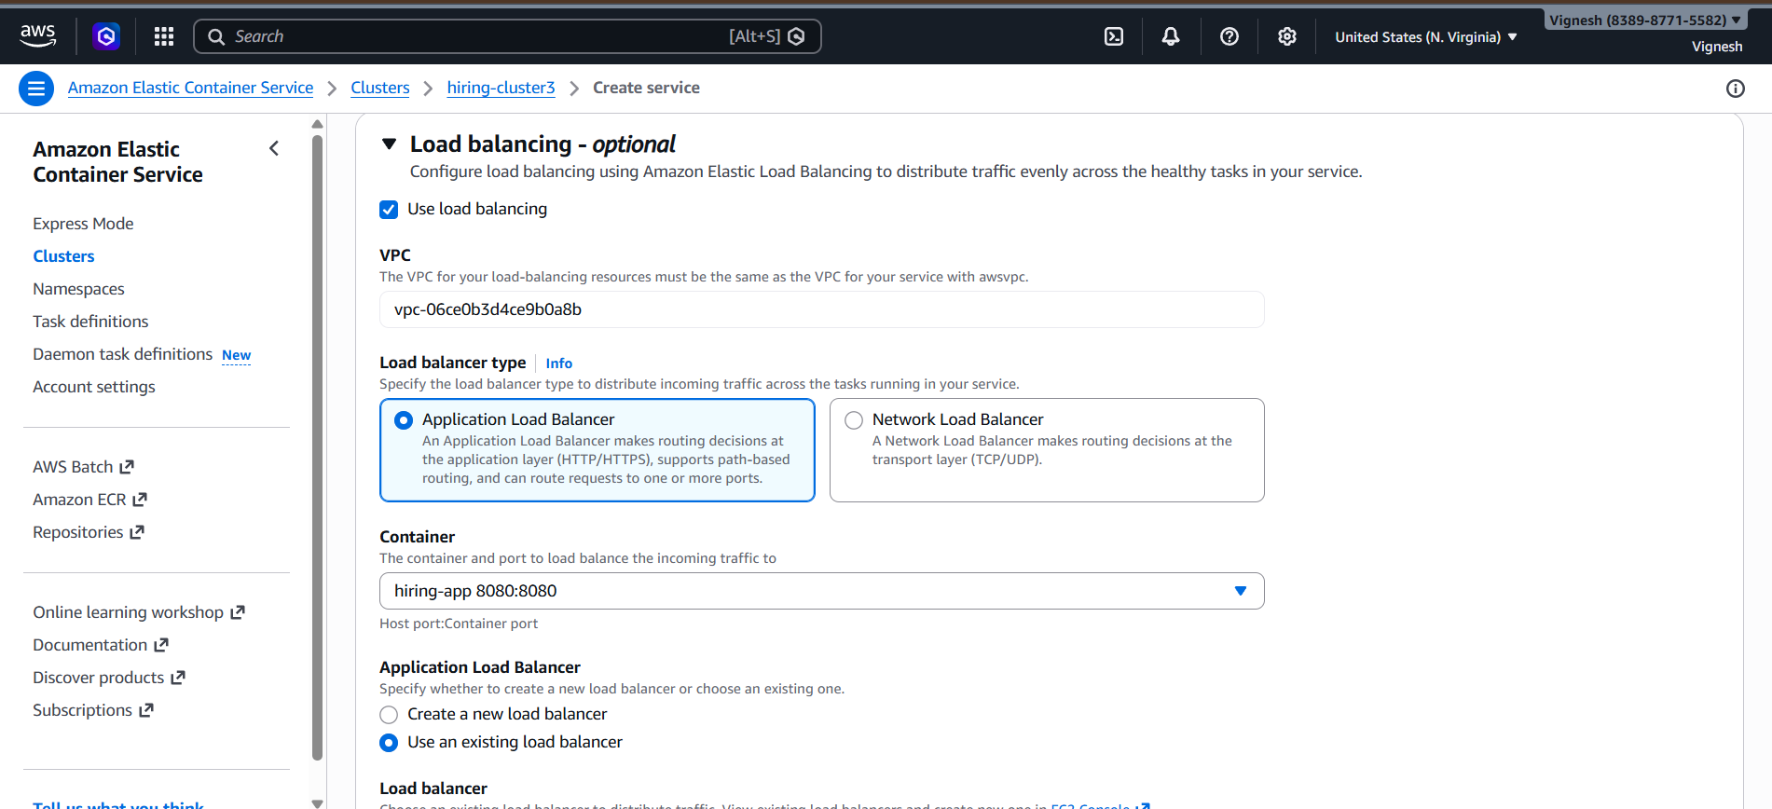
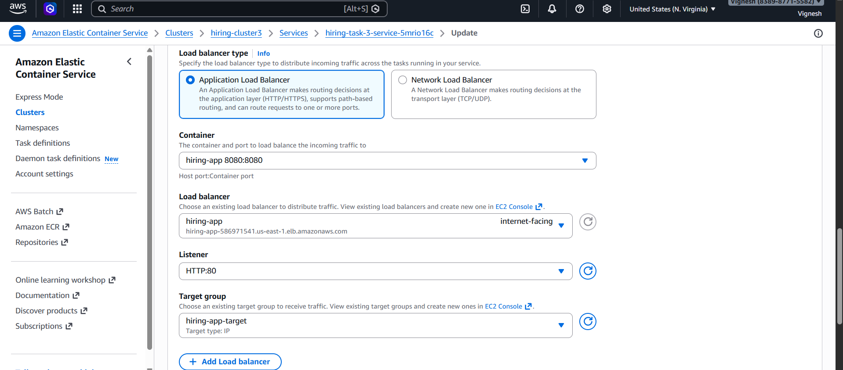

Service created successfully

Step 6: Verification
Check ECS:
- Go to ECS → Services
- Running tasks should be: 6
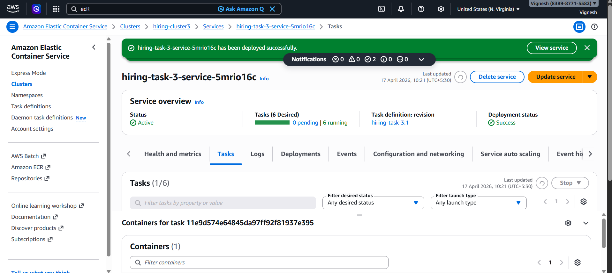
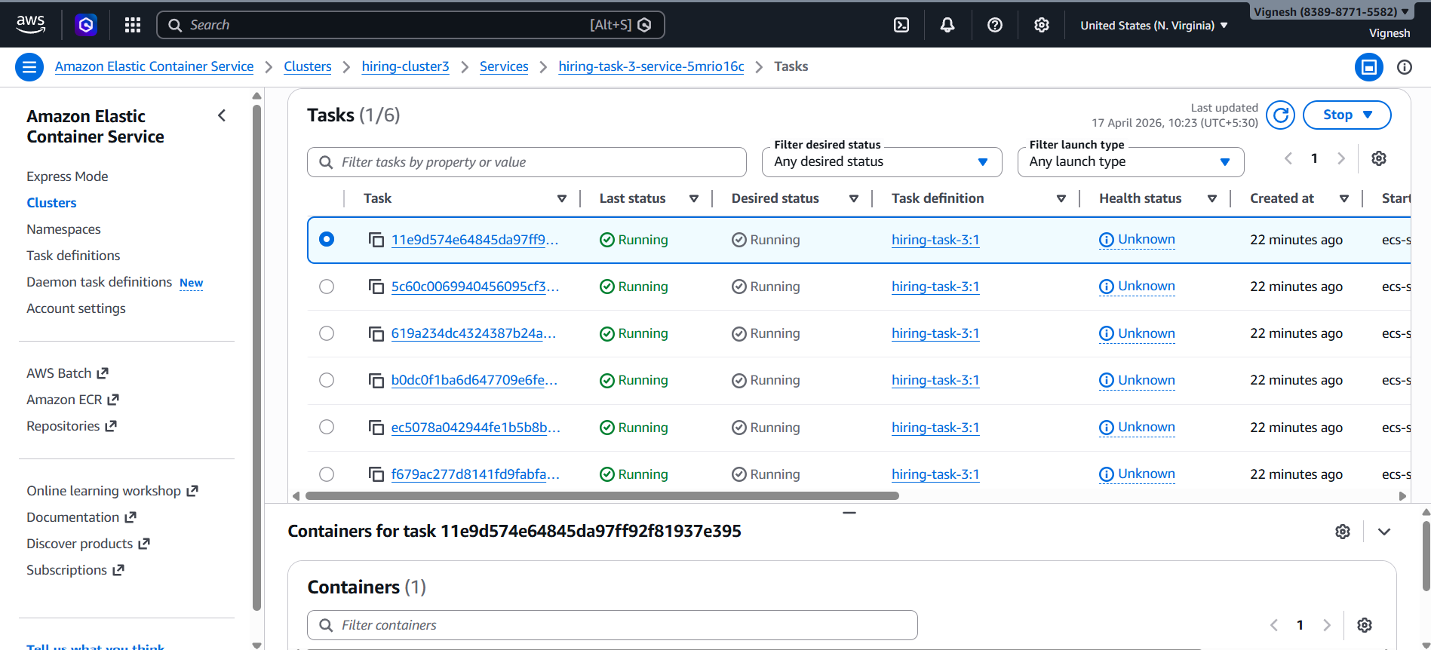
Check Target Group:
- Status: Healthy
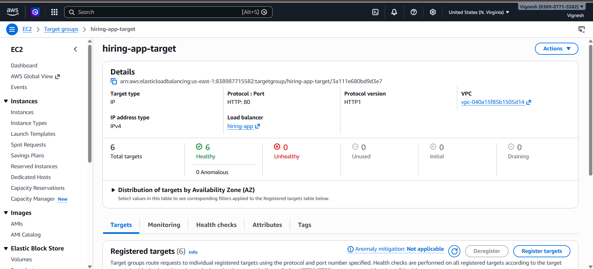
Test Application:
Open in browser:
http://hiring-app-586971541.us-east-1.elb.amazonaws.com:80

http://<ALB-DNS-Name>/hiring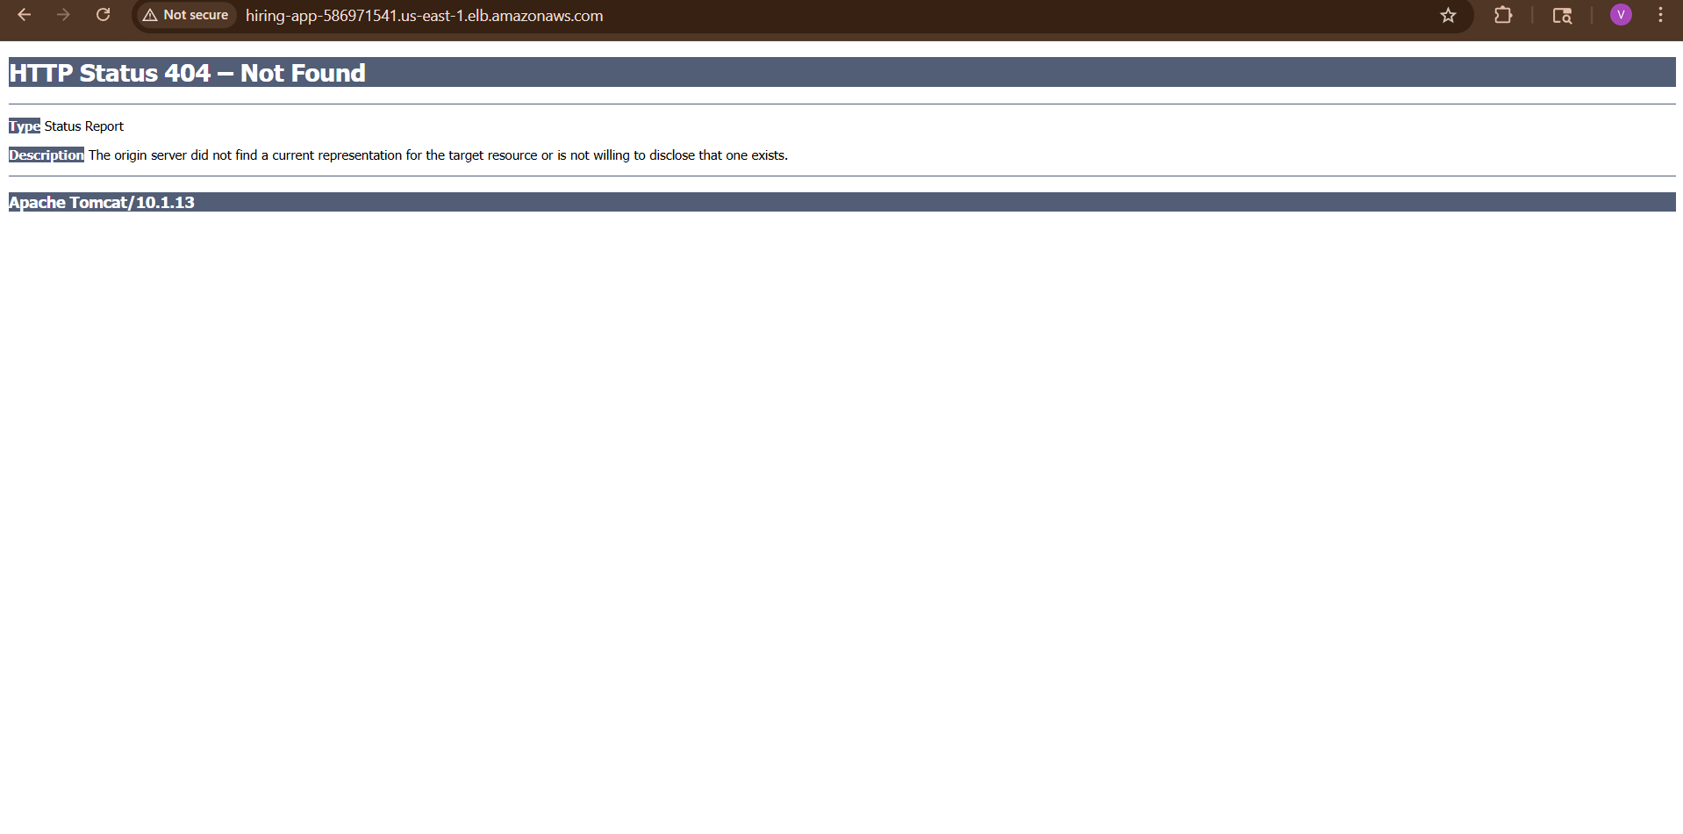
http://hiring-app-586971541.us-east-1.elb.amazonaws.com/hiring/

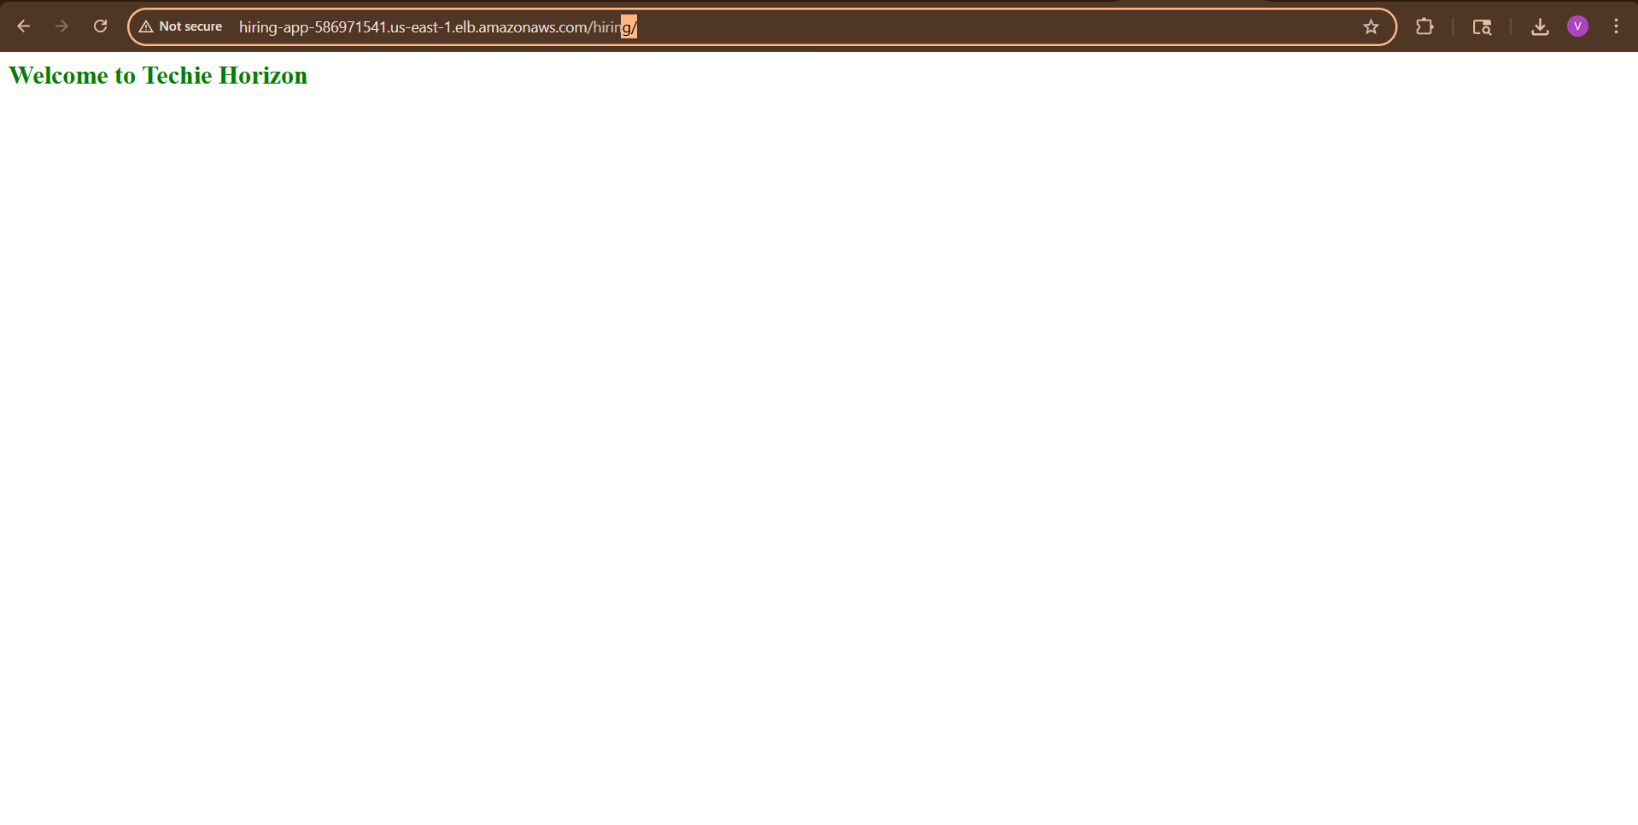

Key Concepts
- Dynamic Port Mapping
→ Host port = 0 → AWS assigns automatically
- High Availability
→ Tasks distributed across multiple AZs
- Load Balancer
→ Distributes traffic across tasks
- Health Checks
→ Ensures only healthy tasks receive traffic

Common Mistakes (Very Important)
- ❌ Wrong target type (should be IP for Fargate)
- ❌ Health check path incorrect
- ❌ Container not listening on correct port
- ❌ Not selecting multiple AZs
- ❌ Security group blocking port 80

Verify In Ec2
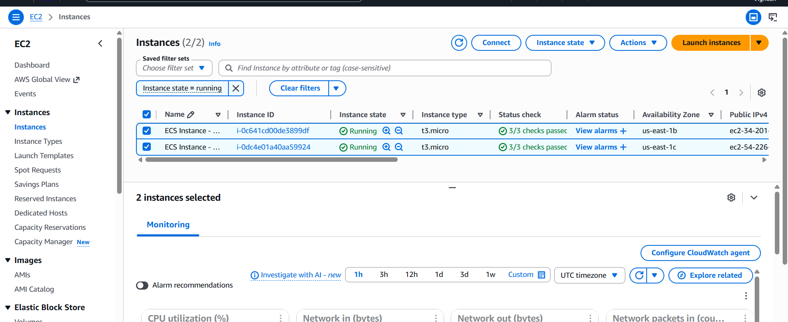

Verify In Cloud Formation
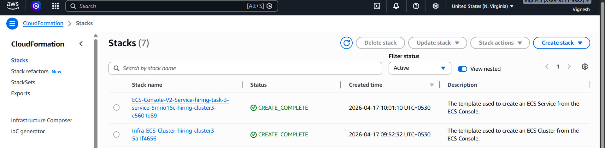

Load Balancer
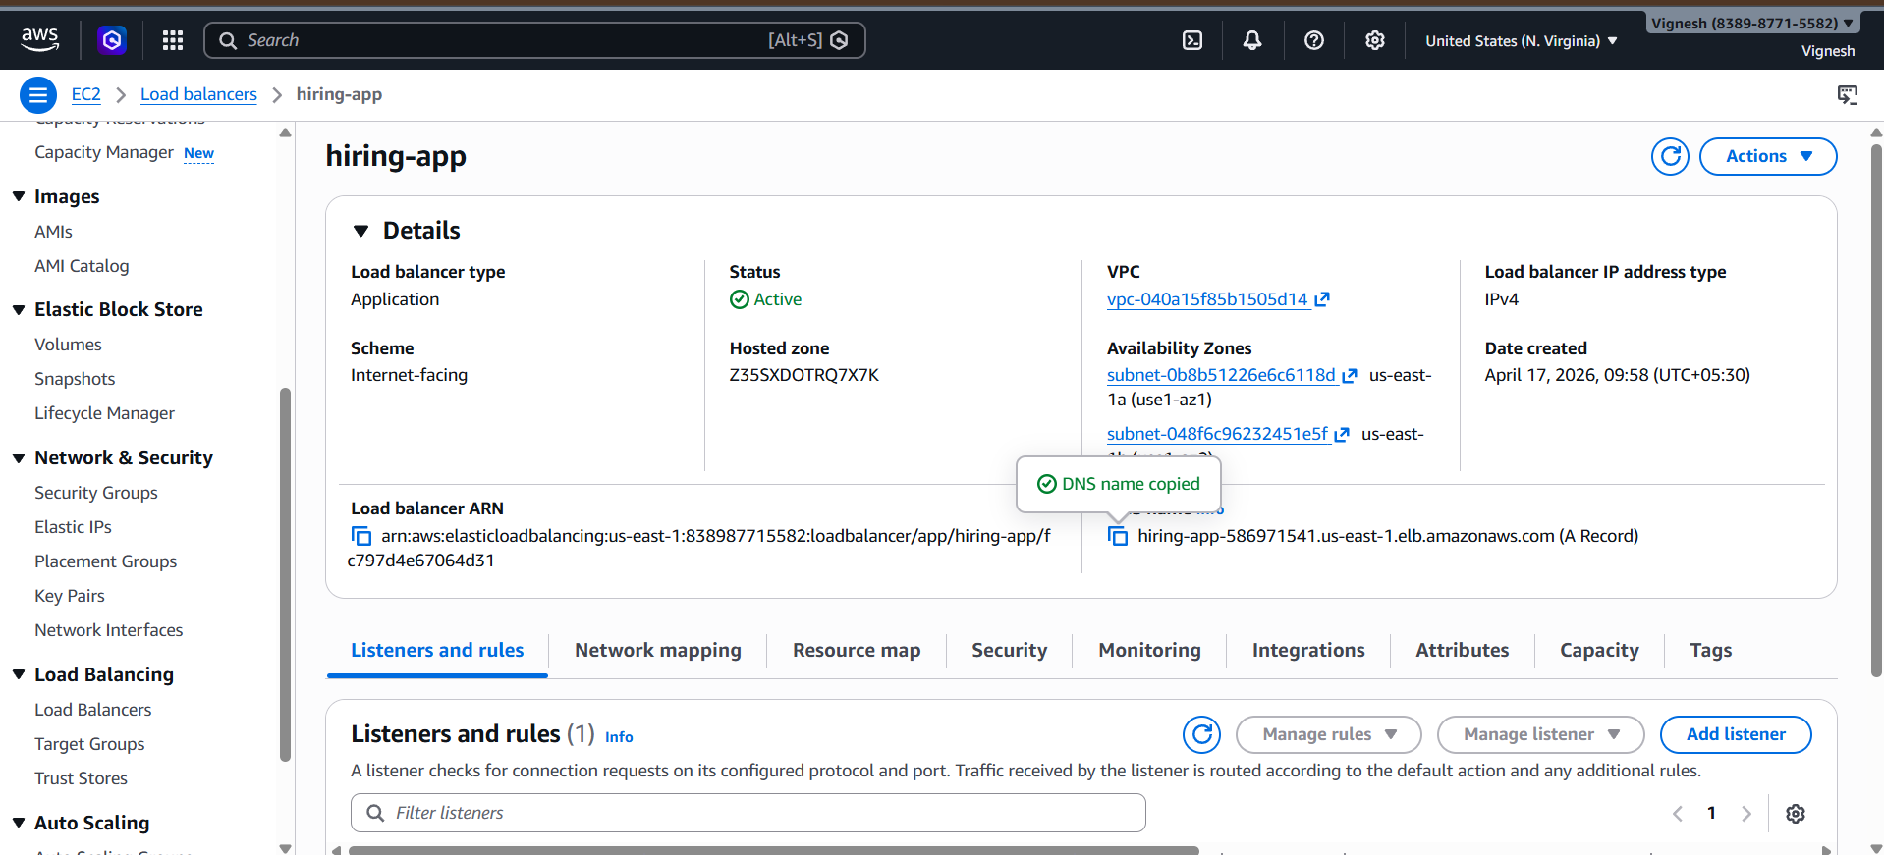

Target Groups
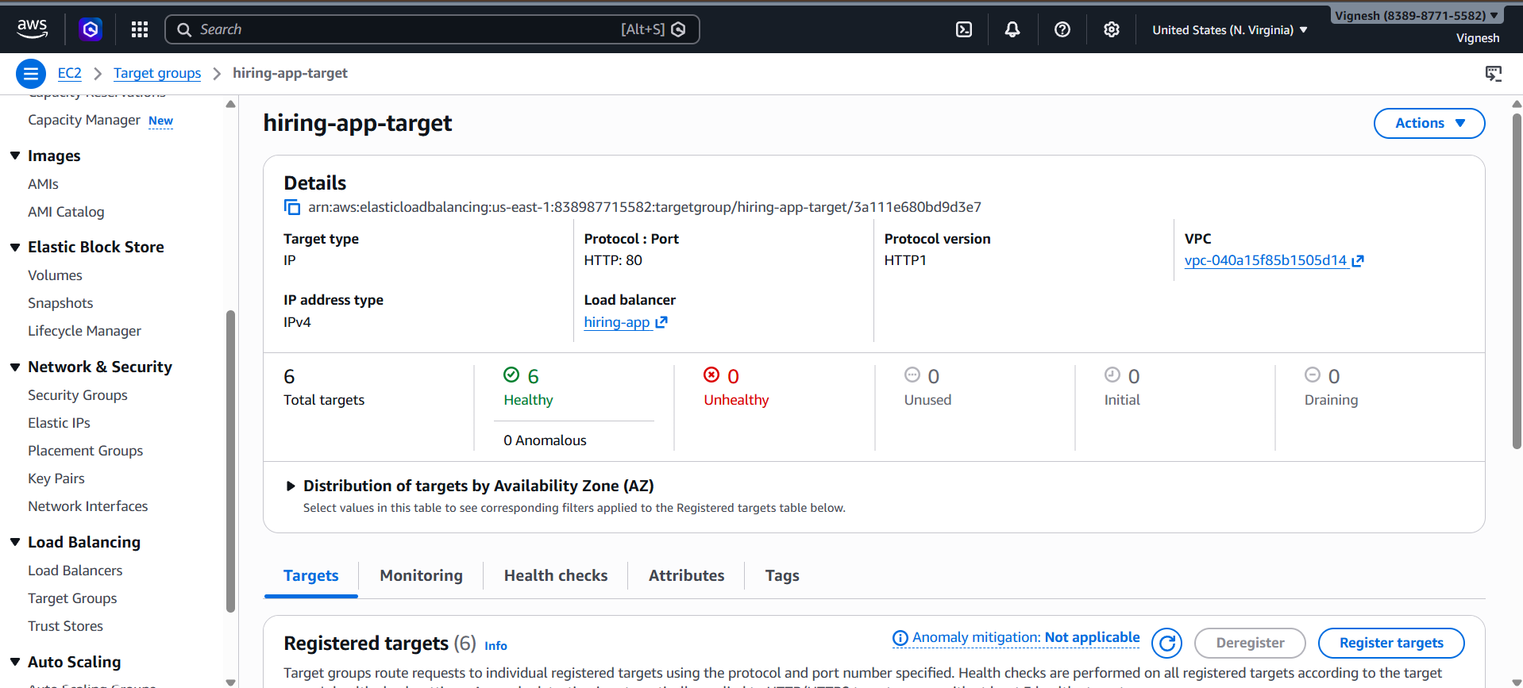
Cluster
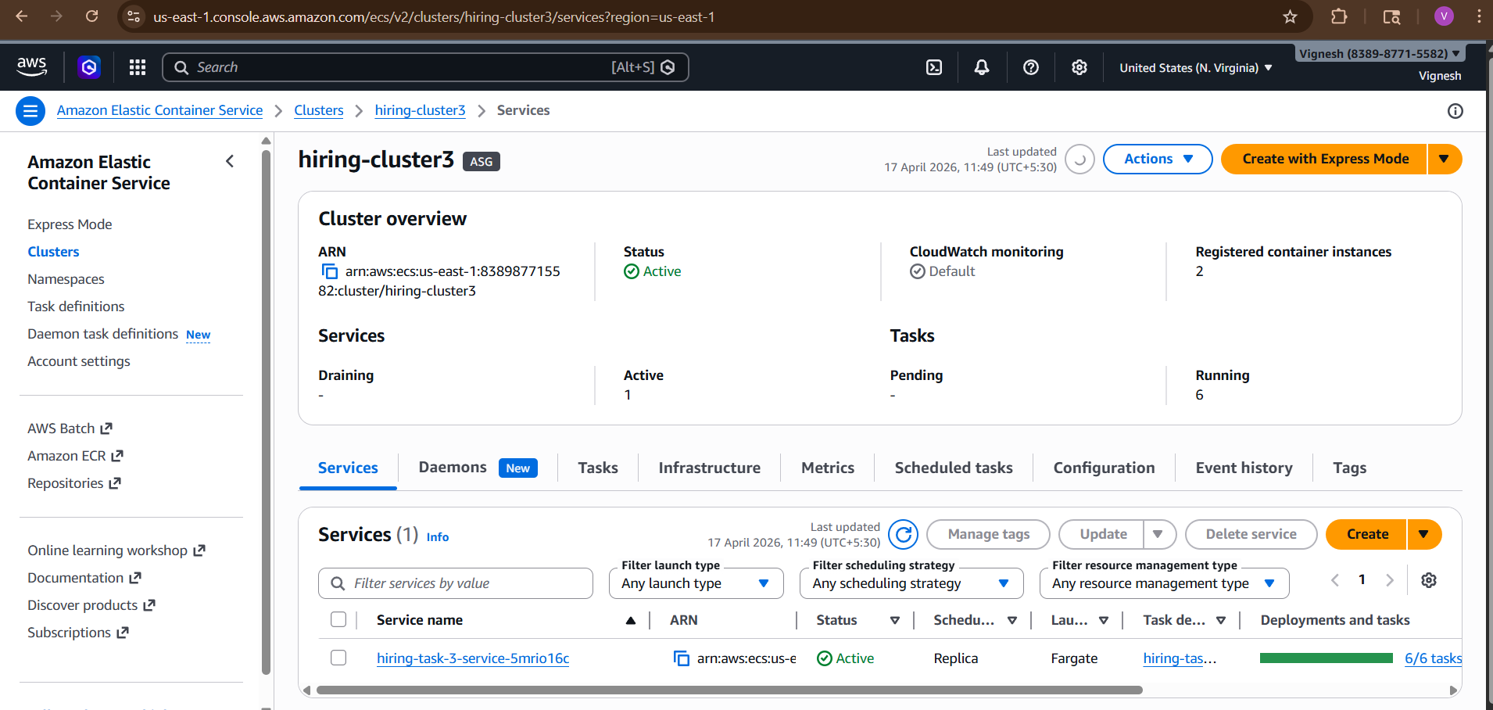

Task Definitions
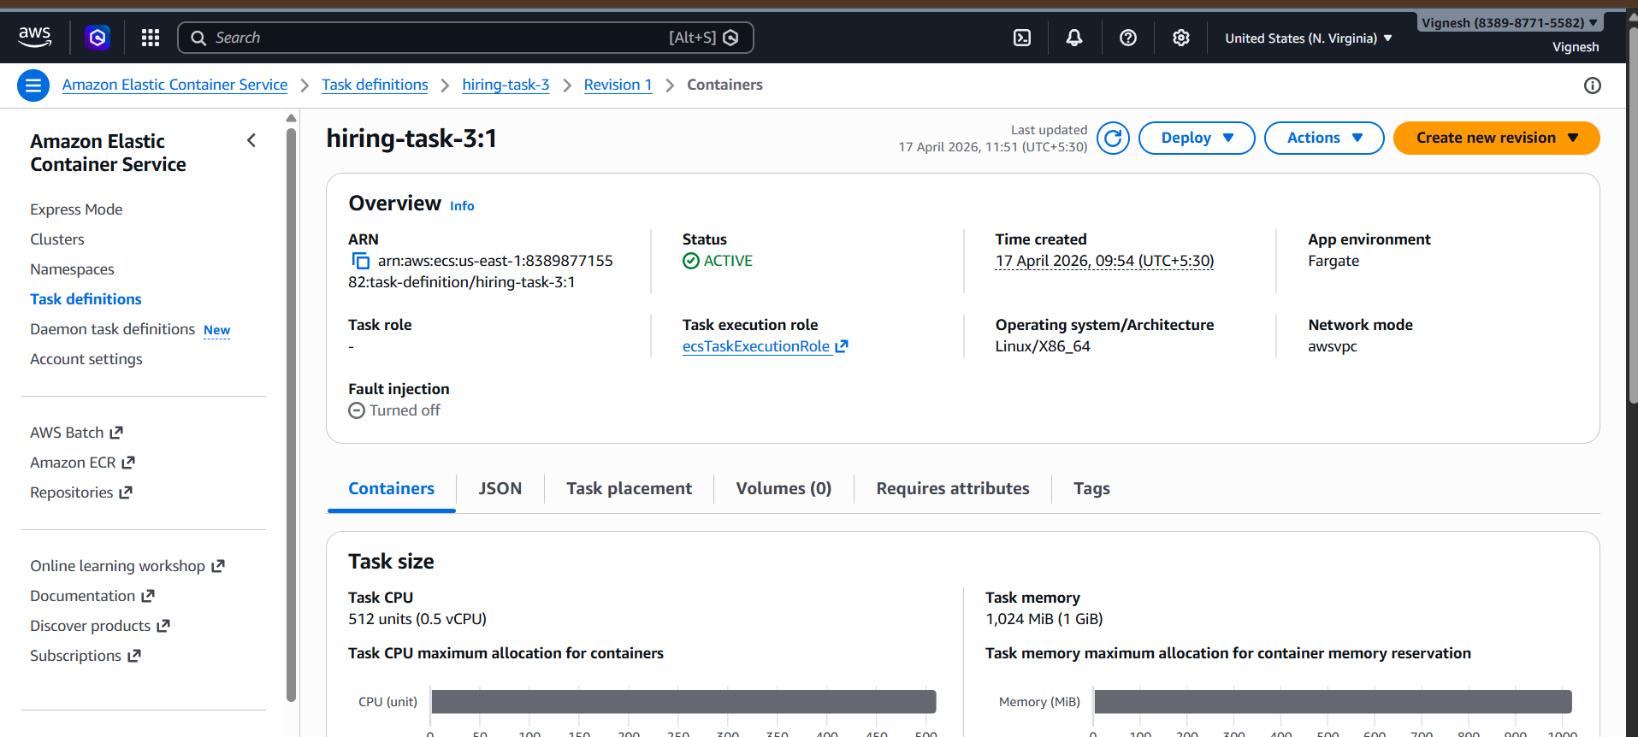
Service
